Network Testing and Validation Guide
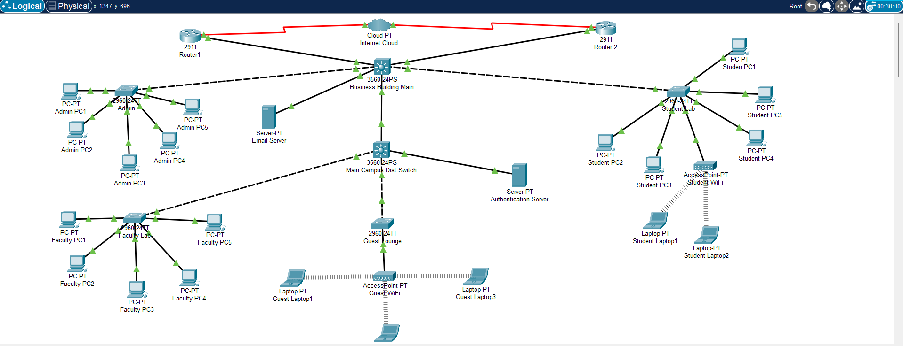
This document provides the step-by-step procedures to verify full functionality of the network.
Use these instructions to confirm that VLANs, trunks, DHCP, routing, and server connections are working properly.
1. VLAN and Trunk Verification
Run the following commands on every switch to verify VLANs and trunks:
- Main Campus Dist Switch
  - Show vlan brief and Show interfaces trunk
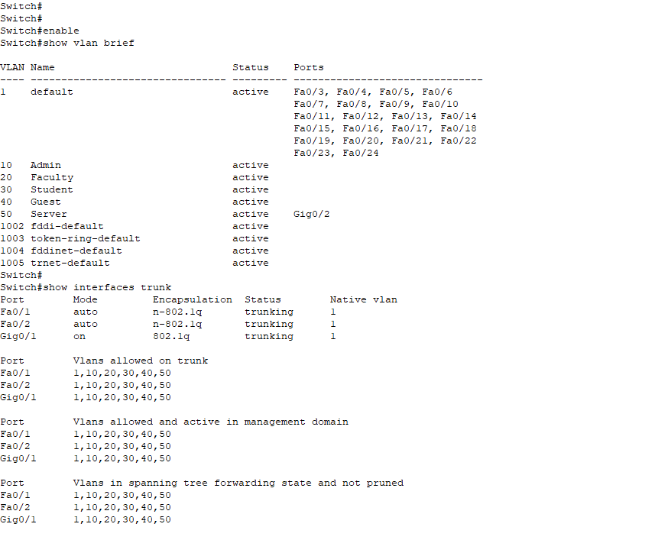

- Business Building Main
  - Show vlan brief and Show interfaces trunk

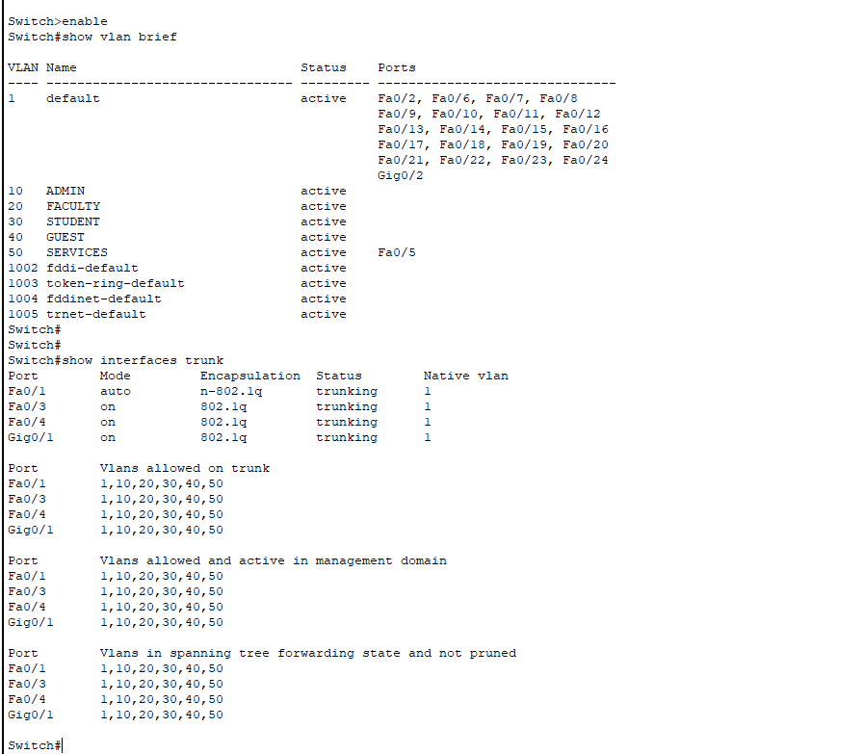
Check that VLANs 10, 20, 30, 40, 50 are active and that all trunk ports allow 1,10,20,30,40,50.

2. DHCP Verification
Ensure each VLAN is receiving DHCP addresses from the Main Campus Dist switch.
On each PC or laptop, go to Desktop → IP Configuration → DHCP and check that the IP, subnet, and gateway are correct.
Expected DHCP Ranges:
VLAN 10 (Admin) → 10.0.10.x / Gateway 10.0.10.1
VLAN 20 (Faculty) → 10.0.20.x / Gateway 10.0.20.1
VLAN 30 (Student) → 10.0.30.x / Gateway 10.0.30.1
VLAN 40 (Guest) → 10.0.40.x / Gateway 10.0.40.1
VLAN 50 (Servers) → 10.0.50.x / Gateway 10.0.50.1
- ADMIN
  - PC-PT Admin PC1
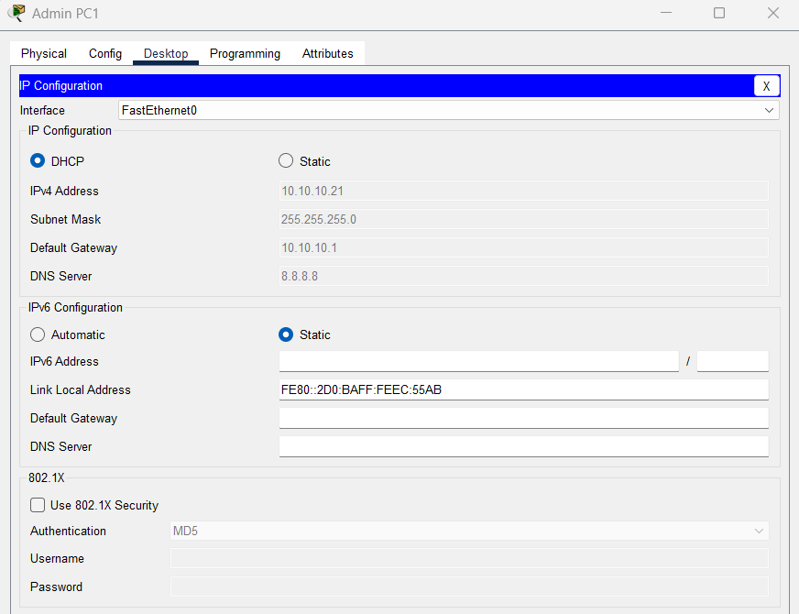

  - PC-PT Admin PC5
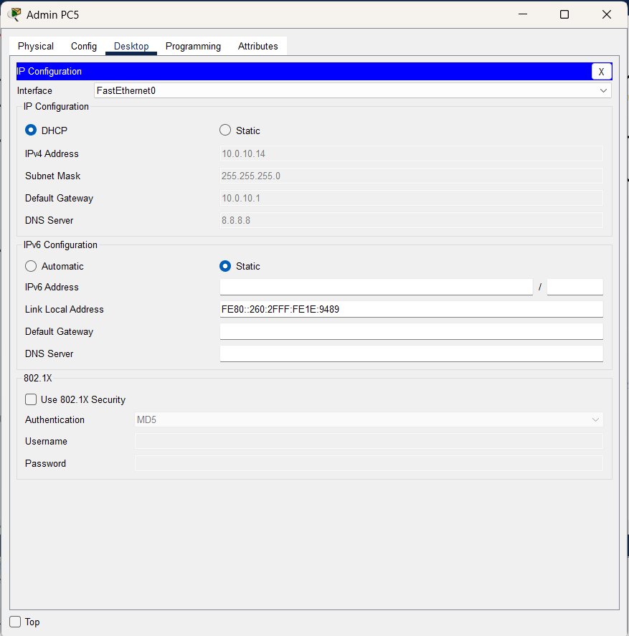

- FACULTY LAB
  - FACULTY PC3
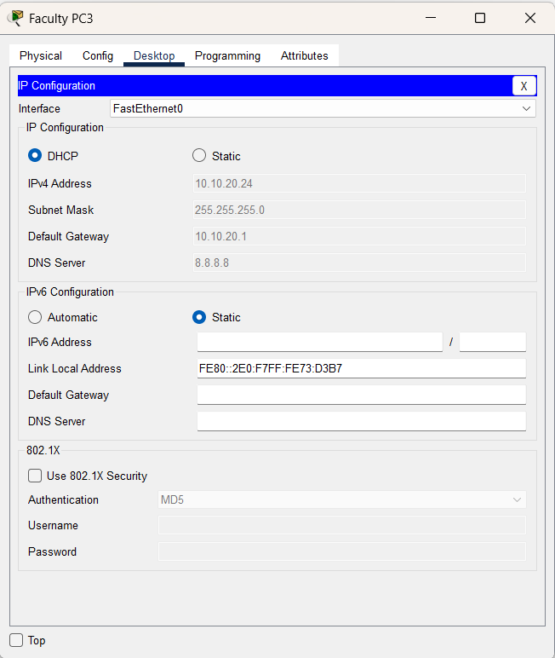

  - FACULTY PC4
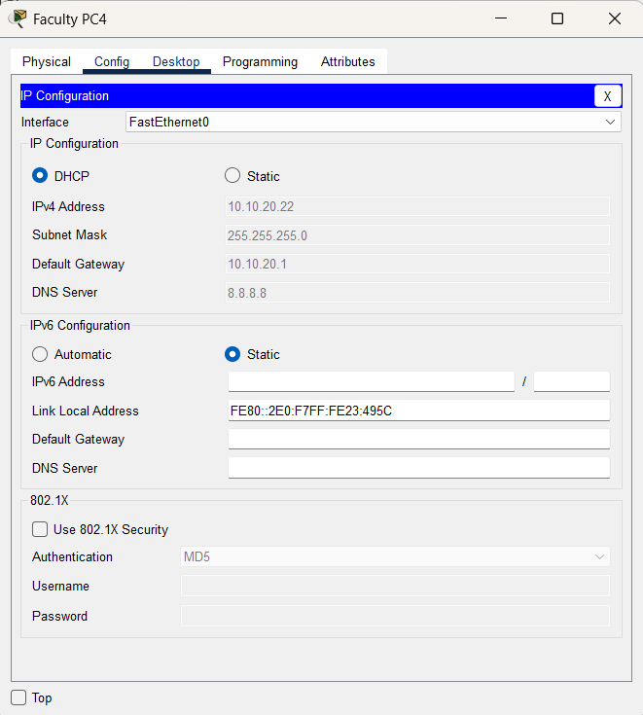

- GUEST LOUNGE
  - Guest Laptop 1
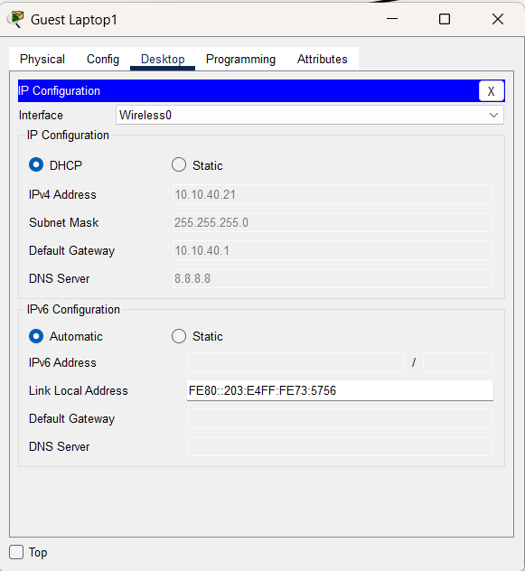
  - Guest Laptop 2
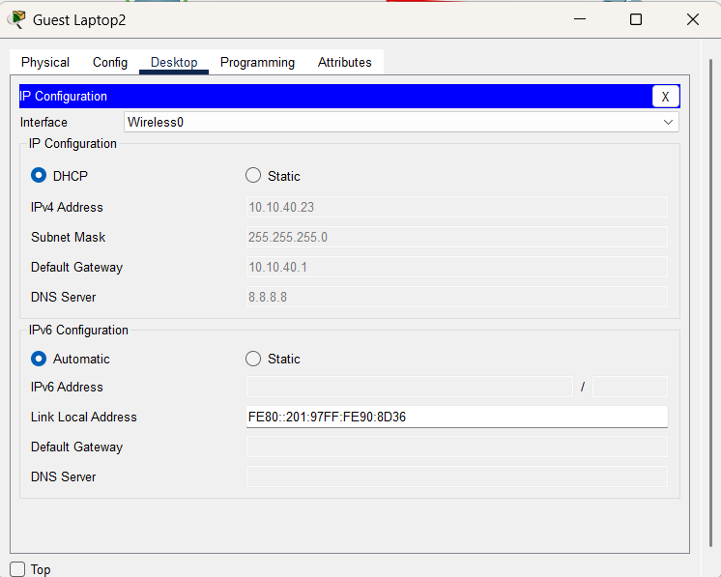

- STUDENT LAB
  - STUDENT PC4
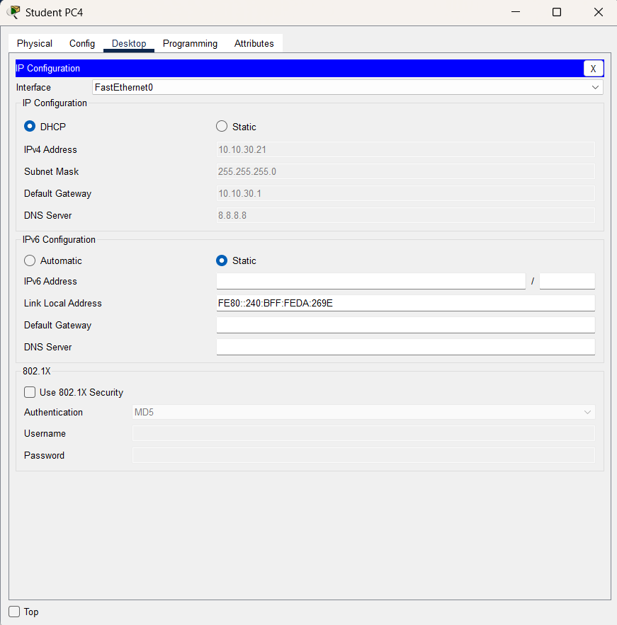
  - STUDENT LAPTOP2
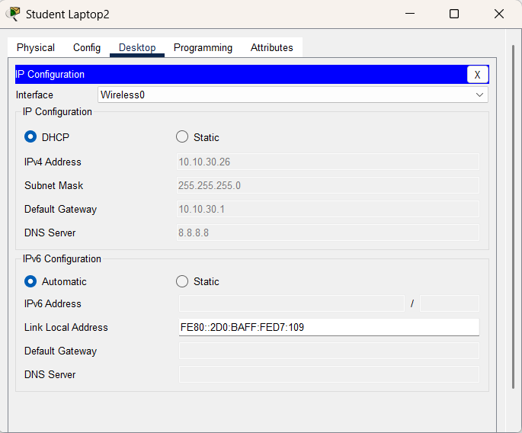
3. Inter-VLAN Routing Test
From any PC (for example, an Admin PC), test connectivity between VLANs using ping:
ping 10.0.10.1
ping 10.0.20.1
ping 10.0.30.1
ping 10.0.40.1
ping 10.0.50.1
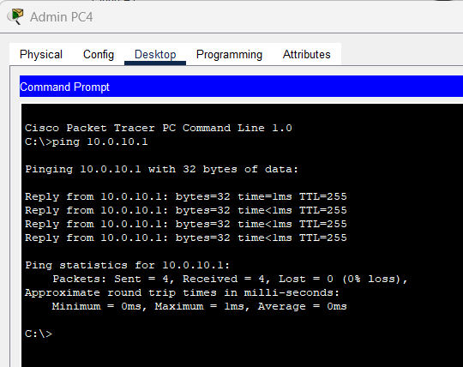
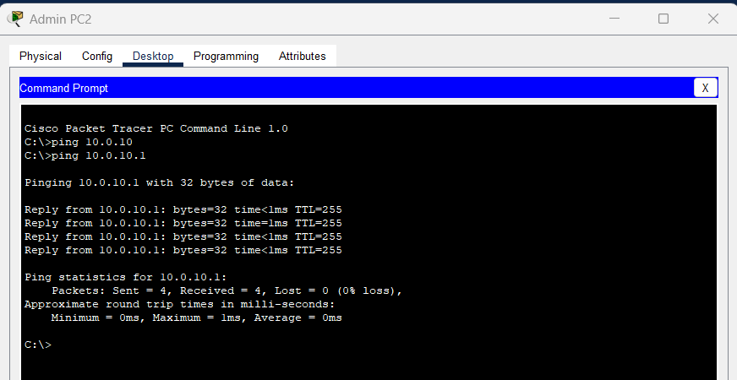
If any ping fails, run 'show ip interface brief | include Vlan' on Main Campus Dist to confirm SVIs are up/up.
If not, use 'interface vlan <number>' followed by 'no shutdown'.
Only pings from Admin are working – even tho all Vlans are up/up with no shutdown
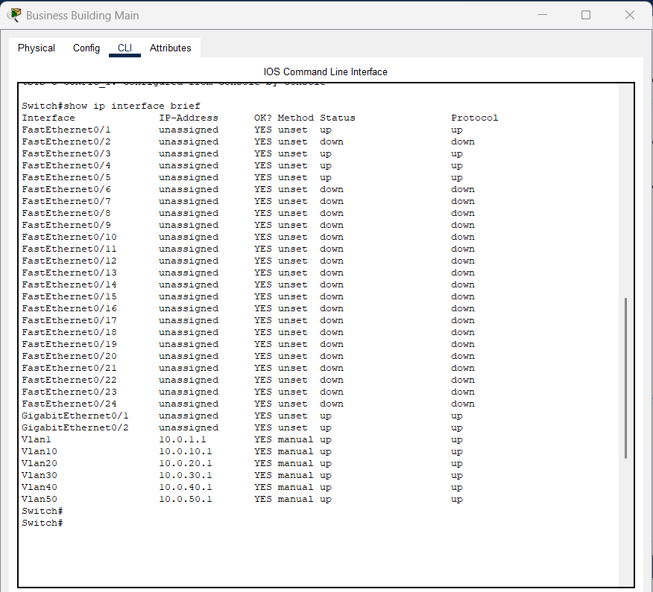

4. End-to-End Device Testing
Confirm all devices can reach each other. From Admin PC, ping:
ping 10.0.30.11 (Student Laptop)
ping 10.0.40.12 (Guest Laptop)
ping 10.0.50.10 (Email Server)
ping 10.0.50.20 (Authentication Server)
From Student Laptop, ping:
ping 10.0.10.11 (Admin PC)
ping 10.0.20.11 (Faculty PC)
5. Server VLAN (50) Test
From Admin PC, verify communication with both servers:
ping 10.0.50.10 (Email Server)
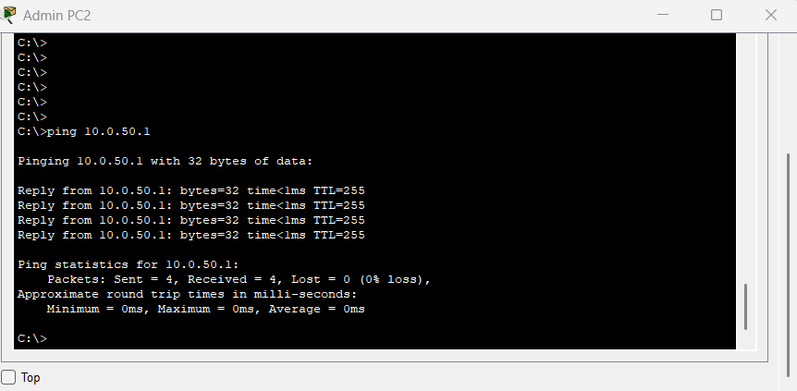
ping 10.0.50.20 (Authentication Server)
From each server, confirm it can reach all gateways:
ping 10.0.10.1

ping 10.0.20.1
ping 10.0.30.1
ping 10.0.40.1
ping 10.0.50.1
6. Internet Simulation (Optional)
If routers and Cloud are configured, confirm external routing:
ping 8.8.8.8
If unsuccessful, check static routes using 'show ip route' and correct next-hop addresses on each router.
7. Save and Document
Once testing passes, save configurations and take screenshots for your report:
wr mem
Required Screenshots:
- show vlan brief
- show interfaces trunk
- show ip dhcp binding
- Ping tests between VLANs and servers
- DHCP confirmation on PCs and laptops
Save the Packet Tracer file as 'Project1_Final_Network.pkt'.

